

Special Education Policy
For Coralstown National School

Introductory Statement:
In line with S.E.N. Guidelines (2025) the policy has been subsequently reviewed and ratified in April 2025.

School Information:
Coralstown National School is a Roman Catholic co-educational primary school. It is a mainstream primary school catering for a full cross section of children. The profiled SET allocation for Coralstown National School for the year 2025/2026 is 30 hours. This equates to a full time Special Education Teacher (S.E.T). Our school currently has 4 SNAs.

Rationale:
The purpose of this policy is to:
- provide practical guidance to staff, parents and other interested parties about our SEN procedures and practices.
- outline the framework for addressing additional needs in our school.
- comply with legislation (Education Act 1998, Equal Status Act 2000).
- fulfil DES Circular 0013/17 – Circular to the Management Authorities of all Mainstream Primary Schools, Special Education Teaching Allocation and new 2017 Guidelines for Primary Schools: Supporting Pupils with Special Educational Needs in Mainstream Schools.
- fulfil DES Circular 0052/19: Exemptions from the study of Irish.

Belief Statement:
Our school is dedicated to the implementation of an effective system for meeting the needs of all our pupils in accordance with our mission statement, the resources provided by the Department of Education and Skills (DES) and the Board of Management.

We believe that all our children have a right to an education, which is appropriate to their individual needs. We strive to ensure that all our children feel that they are a valued part of our school community. We are fully committed to the principle of inclusion. This policy aims to enable children with Special Education Needs (SEN) and children whose first language is not English, to become fully integrated members of our school community. This will be achieved by careful consideration of the needs of each child and by either modifying the environment, activities or by providing support that will help the child to participate in them.

A) Aims of the Policy:
This policy aims to outline our procedures and practices of how we:
- support the inclusion of SEN pupils in primary schools.
- identify additional needs that our pupils may have.
- allocate resources to effectively meet the needs of children with additional needs.
- divide the roles and responsibilities among our school community in relation to pupils with additional needs.
- track, monitor, review and report on the progress of children with additional needs.
- communicate information between the SET team, Principal, staff and parents/guardians.

B) Aims of SEN Support:
SEN support aims to:
- support the inclusion of SEN pupils in primary schools.
- ensure that the Staged Approach / NEPS Continuum of Support is implemented.
- enable pupils with learning difficulties to achieve adequate levels of proficiency in literacy and numeracy before leaving primary school.
- provide supplementary teaching support in literacy and numeracy and specific needs in such areas as oral language, social interaction, behaviour, emotional development, motor skills and sensory processing needs.
- enable pupils to participate in the full curriculum.
- encourage differentiation in the classroom.
- develop positive self-esteem and positive attitudes about school and learning in pupils.
- support attainment and behavioural, social and emotional functioning.
- enable pupils to monitor their own learning and become independent learners.
- involve parents in supporting their children through consultation and co-operation.
- promote collaboration among teachers in the implementation of whole-school policies on learning support for pupils.
- establish early intervention and prevention programmes designed to enhance learning and to prevent / reduce difficulties in learning.
- guard the self-esteem and self-image of the learner.

Roles and Responsibilities:
The role of supporting learning is a collaborative responsibility shared by all of the school community:

The Board of Management, Principal, Class teachers, Special Education Teachers, SNAs, Parents, Pupils and External Bodies and Agencies.
It is important that everyone contributes to the implementation of our school plan on SEN Provision.

a) Board of Management:
The Board of Management oversees the development, implementation and review of the SEN policy. They also ensure that satisfactory classroom accommodation, effective teaching resources and secure facilities for the storage of records relating to pupils in receipt of SEN are provided.

b) Principal Teacher:
As outlined in the DES Circular 0013/17, the Principal has overall responsibility for SEN procedures and practices in the school. The new allocation model states the Principal’s leadership role is central and includes the following:
The school Principal is required to:
- Assume overall responsibility for the development and implementation of the school’s policies on special needs in co-operation with the support teachers.
- Work with teachers and parents in the development of the school plan on supplementary teaching support and special needs.
- Monitor the implementation of the school plan on SEN and special needs on an on-going basis.
- Monitor the selection of pupils for supplementary teaching while ensuring that pupils with the greatest needs receive the greatest supports.
- Oversee the implementation of a whole-school assessment and screening programme to identify pupils’ needs and provide them with appropriate supports.
- Keep teachers informed about the external assessment services that are available and the procedures to be followed for initial referrals.
- Liaise regularly with the support teachers (every half term).
- Arrange classroom accommodation for support teachers.
- Arrange for the provision of SEN funding and resources.
- Organise and co-ordinate the construction of support plans. Ensure that individualised planning takes place.
- Ensure that pupils who have been allocated SEN provision receive it.
- Organise the funding and provision of appropriate assessment tests.
- Complete application forms for outside agencies such as NCSE, NEPS, CAMHS etc.
- Assume direct responsibility for co-ordinating SEN and special needs services.
- Maintain a list of pupils who are receiving supplementary teaching and / or special educational services.
- Co-ordinate the caseloads / work schedules of the support teachers.
- Advise parents on procedures for availing of special needs services.
- Liaise with external agencies such as psychological services to arrange assessments and special provision for pupils with special needs.
- Co-ordinate and organise SNAs' work and timetabling.
- Develop inclusive whole-school policies and monitor their implementation.
- Assign staff strategically to teaching roles including special education roles.
- Co-ordinate teachers’ work to ensure continuity of provision for all pupils.
- Ensure that whole-school procedures are established to facilitate the effective involvement of parents, pupils and external professionals / agencies.
- Ensure that effective systems are implemented to identify pupils’ needs and that progress is monitored.
- Facilitate the continuing professional development of all teachers in relation to education of pupils with special educational needs and ensure that all school staff (class teachers, special education teachers and special needs assistants) are clear regarding their roles and responsibilities in this area.

c) SEN Team
SEN Teachers will be assigned from the SET team to class levels or stage depending on staffing numbers. They should:

- regularly meet with class teachers to discuss the needs of the pupils in their class.
- maintain a record of these meetings and decisions made.
- advise the class teacher, where needed, of possible interventions to meet the needs of their pupils.
- advise the class teacher on procedures for availing of external special needs services.
- support the class teacher in creating a Student Support File once additional support is implemented.
- support the class teacher in the writing of Classroom Support plans.
- where requested by the class teacher, meet parents to discuss moving a child from Classroom Support to School Support or when referring to an outside agency.
- communicate with the SEN team regarding any concerns raised by class teachers at SET team planning meetings.
- update and maintain class SEN records and test results.
- liaise with external agencies about the provision for pupils with additional needs.

d) Role of the Class Teacher
Class teachers have primary responsibility for the teaching and learning of all pupils in his/her class, including those selected for additional support. They should:

- implement teaching programmes which optimise the learning of all pupils and, to the greatest extent possible, prevent the emergence of learning difficulties.
- create a positive learning environment within the classroom.
- differentiate teaching strategies, approaches and expectations to the range of experiences, abilities, needs and learning styles in their class.
- administer and correct standardised tests of achievement in literacy and numeracy, following the school's guidelines.
- discuss outcomes of standardised testing with the SEN Team to assist in the selection of children for supplementary teaching.
- meet with parents regarding any concerns about their child and update them regarding their progress.
- gather information and assess children presenting with needs to inform teaching and learning using the Continuum of Support.
- open a Classroom Support File once additional needs have been identified and require Classroom Support.
- develop Classroom Support plans for children in receipt of Classroom Support.
- collaborate with staff to develop Individual School Support Plans and IEPs for each pupil in receipt of School Support/School Support Plus.
- meet with Special Education Teachers, parents/guardians and other staff members to identify priority learning goals for each pupil in receipt of School Support and who require a School Support Plan.
- collaborate with Special Education Teachers and relevant staff to develop an Individual Education Plan (IEP) for each pupil in receipt of School Support Plus.
- regularly meet with Special Education Teachers, relevant staff and parents to review School Support Plans.
- meet regularly with Special Education Teachers, relevant staff and parents to review School Support Plus Plans.
- where applicable, collaborate with the SET team regarding teaching aims and activities for team teaching.
- adjust the class timetable to ensure that children in receipt of supplementary teaching will not be absent for the same subject/activity during each session.
- co-ordinate the role and responsibilities of the SNA in relation to the needs of pupils with SEN within the class(es) to which they are assigned.
- liaise with and seek advice from their SEN Team.

e) Role of Special Education Teacher (S.E.T)
The S.E.T teacher should:

- familiarise themselves with a wide range of teaching approaches, methodologies and resources to cater for particular learning styles and to meet a variety of needs.
- assist in the implementation of a broad range of whole school strategies aimed at prevention and early intervention.
- collaboratively develop Individual School Support Files for each pupil selected for school support teaching with class teachers and other staff.
- meet with class teachers, parents/guardians and other staff members to identify priority learning goals for each pupil in receipt of School Support.
- collaborate with class teachers, relevant staff and parents/guardians to develop an Individual Education Plan for each pupil in receipt of School Support Plus.
- regularly meet with class teachers, relevant staff to review IEPs.
- meet twice a year with class teachers, relevant staff and parents to review IEPs.
- update and maintain planning and progress records for each individual or group of pupils in receipt of school support.
- provide supplementary teaching for literacy and numeracy on a withdrawal and in-class support basis.
- support whole-school procedures for screening.
- administer and interpret diagnostic tests and inform class teachers and parents of the outcomes.
- meet with parents regarding any concerns about their child and update them regarding their progress.
- co-ordinate class groups and offer advice and support to class teachers regarding pupils on their caseload.
- discuss the needs and progress of children on their caseload at planning meetings.
- provide necessary information to a SEN pupil’s receiving school once a transfer letter has been received.

f) Role of the Special Needs Assistant (SNA)
The duties of the SNA carried out according to the guidelines for Special Needs Assistants from the Department of Education and Skills and under the direction of the principal/class teachers, the SNA will meet the care needs of the SEN pupils to which they have been assigned. (Circular 0030/2014).

An SNA’s role is to carry out:
- Primary Care Needs of the pupil which may include assistance with feeding, toileting and general hygiene, mobility and orientation, moving and lifting of pupils, operation of hoists and equipment, severe communication difficulties, assisting teachers to provide supervision in the class, playground and school grounds administration of medicine, non-nursing care needs associated with specific medical conditions, care needs requiring frequent interventions including withdrawal of a pupil from a classroom when essential.
- Secondary Care Associated Tasks which may be carried out include preparation and tidying of workspaces and classrooms or assisting a pupil who is not physically able to perform such tasks to prepare and tidy a workspace, to present materials, to display work or to transition from one lesson activity to another, assistance with the development of Personal Pupil Plans for pupils with Special Educational Needs, assist teachers and/or the Principal in maintaining a journal and care monitoring system for pupils including details of attendance and care needs, planning for activities and classes where there may be additional care requirements associated with particular activities, assistance with enabling a pupil to access therapy or psycho-educational programmes, assistance to attend or participate in out of school activities.

g) Role of Parents/Guardians
Collaboration and sharing of relevant information between home and school are essential elements of our SEN policy. Parents/Guardians through their unique knowledge of their own children have much to contribute to their child’s learning.

Parents can support the work of the school in supporting their child by:

- sharing any information, reports or reports pending from health professionals, and/or concerns regarding their child’s development. Copies of professional reports should be provided to the school at the enrolment stage.
- supporting the work of the school and keeping the class teacher informed of the progress and challenges they observe in their child’s learning.
- attending meetings arranged by the class teacher or SET team.
- supporting the targets outlined in their child’s support plans and engaging in all suggested home-based activities.
- informing the post-primary school of their child’s needs at the transition stage.

h) Role of the Pupil
Pupils who are in receipt of supplementary teaching should, as appropriate:

- be given the opportunity to contribute to the setting of the medium and short-term learning targets.
- become familiar with the targets that have been set for them.
- develop ‘ownership’ of the skills and strategies that are taught during supplementary teaching and learn to apply these learning strategies and skills to improve their own learning.
- contribute to the evaluation of their progress by participating in appropriate assessment activities, including self-assessment.

i ) Role of External Bodies and Agencies
External bodies and agencies should:

- liaise with SEN teachers to optimise the quality of provision for pupils with special educational needs at the individual, group or whole-school level.
- make relevant recommendations in developing support plans at each level of the Continuum of Support.

Identifying Pupils with Additional Needs
We use the Continuum of Support Framework set out by the Department of Education to identify and support children with additional needs. Like this framework, we recognise that special educational needs occur along a continuum, ranging from mild to severe, and from transient to long-term and that pupils require different levels of support depending on their identified additional needs.

This framework helps us implement a staged approach to ensure that our support and interventions are incremental, moving from class-based interventions to more intensive and individualised support and are informed by careful monitoring of progress.

The Continuum of Support Framework encompasses a graduated problem solving model of assessment and intervention which enables us to gather and analyse data as well as to plan and review the progress of individual pupils.

This problem-solving process is illustrated as follows:

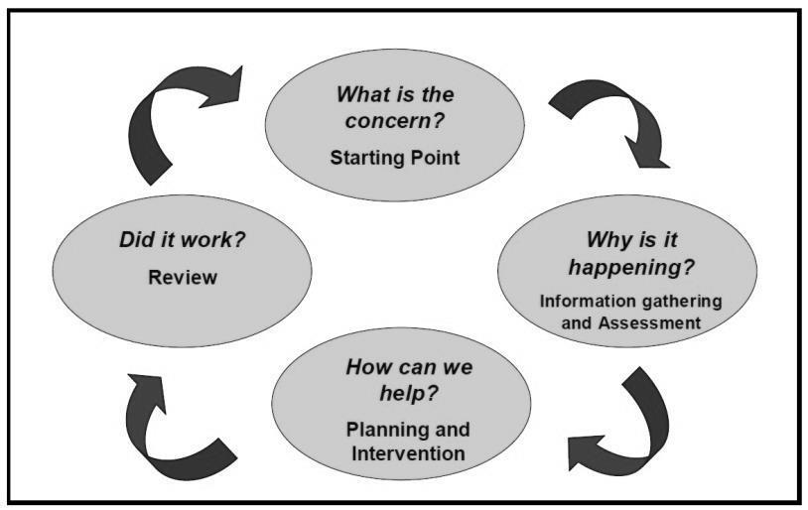

Using the Continuum of Support Framework, we identify pupils’ educational needs including academic, social and emotional needs, as well as needs associated with physical, sensory, language and communication difficulties.
Once needs have been identified the level of intervention and support provided is matched to those needs and their changing nature over time.
We aim to give every child the opportunity to experience success in learning and to achieve as high a standard as possible. (See also Appendix 2 below – Exceptional Ability and Giftedness Policy). The principle that pupils with the greatest level of need have access to the greatest levels of support is of primary importance.

The Continuum of Support Framework suggests the following levels of support:

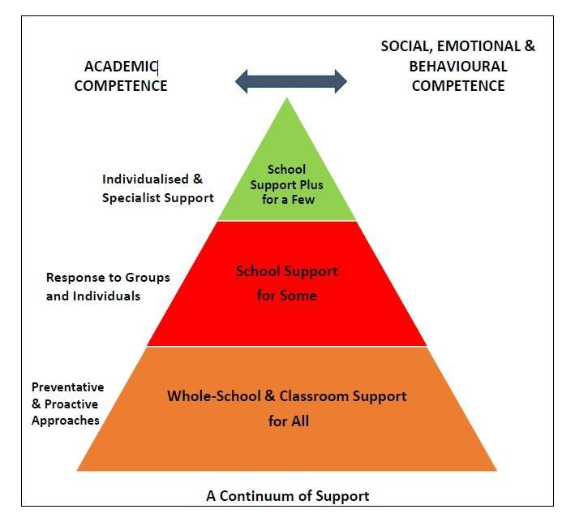
STAGE 1: CLASSROOM SUPPORT
Classroom Support is typically the first response to emerging needs. It is a response for pupils who have distinct or individual educational needs and who require approaches to learning and/or behaviour which are additional to or different from those required by other pupils in their class.

Problem-solving at this level typically begins when a parent or teacher has concerns about an individual pupil. The teacher and parents discuss the nature of the problem and consider strategies which may be effective.

A plan is devised and put in place for a specific timeframe and then reviewed. If strategies are successful it may be decided to continue with supports in place or discontinue any supports in place. If strategies have not resolved the needs of the pupils, then pupils move to the next stage of the Continuum.

STAGE 2: SCHOOL SUPPORT
When interventions at Classroom Support level are not enough to fully meet the pupil’s special educational needs, School Support may be required.

The class teacher needs to involve the Special Education Teacher Team (SET Team) in the problem-solving process. The class and S.E.T gather information, develop and monitor a School Support Plan for a set period of time and then review this plan. If the plan is working, the pupil may remain on the plan or revert back to Classroom Support depending on individual needs.

If needs are not resolved after a specific timeframe, then pupils move to the School Support Plus stage of the Continuum.

STAGE 3: SCHOOL SUPPORT PLUS
If a pupil’s special educational needs are severe and/or persistent, they are likely to need intensive support. School Support Plus will involve personnel outside the school team in the problem solving, assessment and intervention process.

The information from Classroom and School Support work will provide the starting point for problem-solving at this level. Classroom support and school support will continue to be an important element of his/her individual education plan.

The flow diagrams below outline how we gather information to identify needs and support children with additional needs. A more comprehensive explanation of each stage can be found in the Continuum of Support – Guidelines for teachers
https://www.education.ie/en/Schools-Colleges/Services/National-Educational-Psychological-Service-NEPS-/neps_special_needs_guidelines.pdf

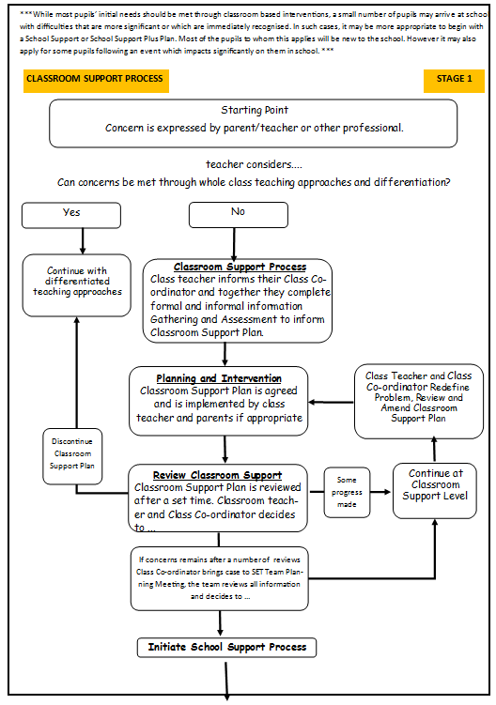

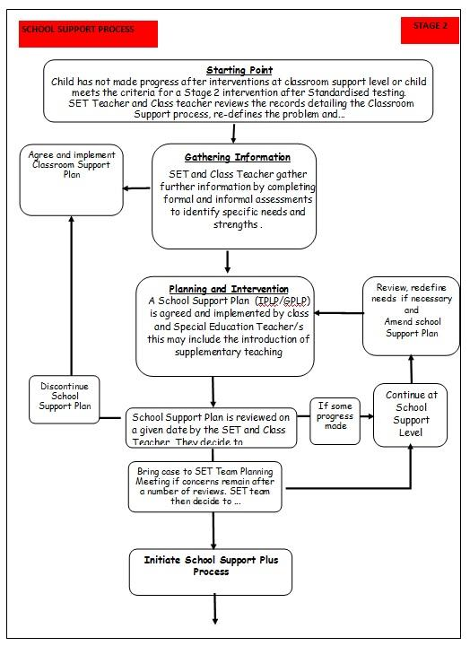

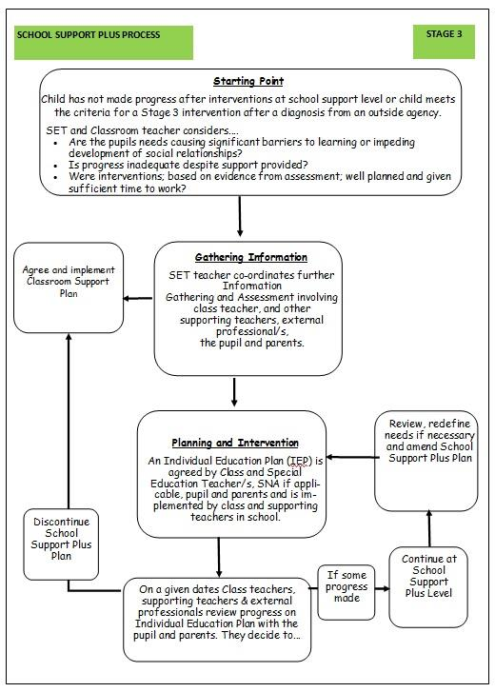

Assessment and Information giving

Parental Permissions
Written parental permissions for school-based assessments and school support, if deemed necessary, are signed by parents on school entry.

Assessment is an integral part of a class teacher’s role on a daily basis for all children. Assessment of Learning and Assessment for learning enable teachers to gather information to plan learning experiences based on the appropriate objectives from the curriculum and based on the needs of the pupils.

Firstly, we look at all pupils in the school and identify any needs.

In order to identify pupils who may require supplementary teaching, screening (including standardised testing) is carried out in all classes annually and further diagnostic testing may need to take place. The information gathered from these formal assessments along with teacher observations are used to prioritise needs and set out pupil’s learning targets.

Initial Screening
Class teachers carry out screening tests and standardised assessments. The S.E.T will administer further screening tests, if deemed necessary.

In our school, we carry out the following assessment procedures:

- Junior Infants: Observation, Checklists, Termly Maths assessments, MIST and Jolly Phonics Assessments to selected pupils who are identified as being in need of special education teaching.
- Senior Infants: Observation, Checklists, Termly Maths assessments, Drumcondra Test of Early Literacy, Drumcondra Test of Early Numeracy.
- 1st class: Observation, Checklists, Termly Maths assessments, Drumcondra Primary Reading Test, Drumcondra Primary Maths Test, Drumcondra Spelling Test.
- 2nd class: Observation, Checklists, Termly Maths assessments, New Non Reading Intelligence Test (NNRIT), Drumcondra Primary Reading Test, Drumcondra Primary Maths Test, Drumcondra Spelling Test.
- 3rd class: Observation, Checklists, Termly Maths assessments, Drumcondra Primary Reading Test, Drumcondra Primary Maths Test
- 4th class: Observation, Checklists, Termly Maths assessments, Drumcondra Primary Reading Test, Drumcondra Primary Maths Test
- 5th class: Observation, Checklists, Termly Maths assessments, New Non Reading Intelligence Test (NNRIT), Drumcondra Primary Reading Test, Drumcondra Primary Maths Test
- 6th class: Observation, Checklists, Termly Maths assessments, Drumcondra Primary Reading Test, Drumcondra Primary Maths Test

Those children who score below the 10th percentile in either English or Maths are prioritised for supplementary teaching.

Sometimes children may be included for support based on a teacher’s experience and insight or where there are exceptional circumstances such as difficult home circumstances, ongoing poor performance not flagged in standardised tests, difficulties with processing etc.

Diagnostic Assessment
The S.E.T discusses each class’s recorded results with the Class teacher and carries out further screening tests and/or diagnostic assessments, where deemed necessary. The results of these tests inform the caseload selection process. The Principal is kept informed at all times during this process.

Inventory of Test Materials

Screening Tests:
- Drumcondra Test of Early Literacy
- Drumcondra Test of Early Numeracy
- Drumcondra Primary Reading Test
- Drumcondra Primary Maths Test
- Single Word Spelling Test SWST
- New Non – Reading Intelligence Test (NNRIT)

Diagnostic Tests:
The following diagnostic tests are administered in Coralstown National School where appropriate:

Literacy Tests:
- Jolly Phonics Assessment – Individual Progress in Phonics
- Dolch List Words – Lists 1 – 11
- Informal Dictation to identify students who have weaker skills in the areas of rate of writing, handwriting legibility, listening skills and spelling skills
- Phonological Awareness Criterion Test
- Accelerated Reader Star Reading Assessments take place five times per year (Reading Comprehension, Vocabulary etc.) – 2nd to 6th Class
- Single Word Spelling Test (SWST) – 2nd to 6th Class
- Schonell Reading Test – 4th to 6th Class
- Schonell Spelling Test – 4th to 6th Class
- Quest Diagnostic Literacy Test – 1st to 2nd Class
- Aston Index – 5 to 12 years
- NRIT 2nd and 5th Classes
- York Assessment of Reading for Comprehension (YARC) – 2nd to 6th Class
- Drumcondra Reading Indicators – All classes
- Early Literacy Test (ELT) – Junior / Senior Infants
- Running Records
- Bangor Dyslexia Screening Test
- Checklists for Speech and Language, Gross and Fine Motor Skills, Social Skills

Numeracy Tests:
- Pupil Questionnaire Attitude to Maths (PDST)
- Ballard Westwood Timed Tables Test
- Basic Number Diagnostic Test (5 – 7 years)
- MaLT (Mathematics Assessment for Learning and Teaching)
Prevention and Early Intervention Strategies

Prevention Strategies
- Differentiation of the curriculum by the mainstream class teacher to cater for individual strengths and needs.
- Development and implementation of agreed approaches to the teaching of English and Mathematics to ensure progression and continuity from class to class, including the Aistear programme in the Infant classes, Guided Reading using the Oxford Reading Tree Readers from Junior Infants to 1st class.
- Accelerated Reader Programme for 2nd-6th class to track ZPD through the school.
- Careful development of phonological awareness, rhyming skills and oral language skills, before formal reading of words and books.
- The use of concrete materials as much as possible and as appropriate.
- Ongoing structured observation and assessment of the language, literacy and numeracy skills of children in the Infant classes to facilitate early identification of possible learning difficulties.
- Close collaboration and consultation between the Infant teacher and the SET team.
- Promotion of literacy e.g. Print-rich environment.
- Promotion of Numeracy.
- Jolly Phonics and Spelling Programme.
- Friends for Life Programme.
- In-class support from the S.E.T based on identified needs.
- Station teaching/Team teaching in the Infant classes with oral language focus.
- Withdrawing individuals/small groups.
- Class-based early intervention by the class teacher focusing on the provision of additional individualised support, as and when required.
- Provision of additional support in language development/early literacy/early mathematical skills to children who need it.
- Support for children experiencing social/emotional difficulties and problems with concentration.
- Provision of Assistive Technology as appropriate.
- Promotion of parental involvement through their attendance at induction meetings for parents/guardians of incoming Junior Infants and the arrangement of formal and informal parent/teacher meetings.
Early Intervention Strategies
Early intervention programmes may be provided by the class Teacher and/or the Support Teacher, in accordance with the Staged Approach (NEPS Continuum).

Collaboration and consultation between the Class teachers and the Support Teachers, should identify children who may be in need of early intervention.

Teacher observation and professional opinion will be given due consideration in the selection of children for early intervention programmes at Classroom Support/School Support level.

Early intervention programmes will include:
- Implementation of an English language programme for Junior Infant and Senior Infant children who have English as an additional language, with emphasis on basic vocabulary. Intensive language programme for such children in more senior classes with emphasis on basic vocabulary and the language of Maths. This acknowledges the literacy skills already acquired in mother tongue.
- Active learning programme for all Junior Infant children with specific emphasis on oral language development, underpinned by the principles of the Aistear programme and the new Primary Language Curriculum.
- Early intervention literacy and language support programme (Guided Reading using PM Readers) in Junior Infants to 2nd Class daily.
- Withdrawal of children to a support teaching room, in-class support, team teaching, group work and individual support will be provided, as appropriate and if it is in a child’s best interest.

Meeting the Needs and Allocating Resources
Once pupils’ needs have been identified, the Special Education Teacher (S.E.T) is deployed to address these needs as required. We aim to strike a balance between in-class support, small group and individual support while ensuring that the needs of children with additional needs are met inclusively.

Importantly, the level and type of support reflect the specific targets of individual pupils as set out in their support plans and are informed by careful monitoring and review of progress. In this way, following a period of intervention, some pupils may no longer require additional teaching supports; some may require the same level while others may require more intensive supports.

In planning the allocation of additional teaching supports, the over-riding principle is that resources are deployed to address the identified needs of pupils. Importantly, those with the highest level of need should have access to the greatest level of support. We consider methodologies best suited to promoting meaningful inclusion such as differentiation, heterogeneous grouping, team-teaching and small group teaching. In addition to literacy and numeracy difficulties, many pupils will have specific needs in such areas as oral language, social interaction, behaviour, emotional development, motor skills, sensory processing needs and application to learning.

In February of each year, the S.E.T meets the class teachers to review pupils’ needs, the resources in place and the progress made using the Continuum of Support problem-solving model of assessment. The S.E.T then brings this information to the end of term SEN team and principal planning meetings. As a SEN team, we review all support and allocate resources for the subsequent term.
We cross-reference the needs of pupils at School Support and School Support Plus levels and consider common needs that can be met by grouping to ensure effective and efficient teaching and learning approaches.

Appendix 1: Identifying and Selecting Children for Additional Teaching Support

The following criteria will be used by our school to select children for supplementary teaching in line with the new model of Special Education Teaching (Circular 13/2017 p.15/16)

Stage 3:  School Support Plus | 1. Children with identified complex needs by an external professional such as a:  - Physical Disability (e.g. Dyspraxia)  - Hearing Impairment  - Visual Impairment  - Emotional Disturbance  - Moderate General Learning Disability  - Severe/Profound General Learning Disability  - Autistic Spectrum Disorder  - Assessed Syndrome  - Specific Speech and Language Disorder/Impairment  Children whose Additional Educational Needs have not yet been diagnosed but who are on a waiting list for outside agency support are also included in this category. | Individual Education Plans | Type of Support  In-Class Support  Team-Teaching  Group Withdrawal  Individual Withdrawal  Personnel  S.E.T  Class Teacher  Outside Agencies  Type of support is dependent on the child’s needs.
Stage 2:  School Support | 2. Children on or below the 10th percentile in Literacy and Numeracy Standardised Tests.  3. Pupils who were previously in receipt of supplementary teaching from a resource or learning support teacher and who continue to experience significant learning difficulties.  4. Prevention and Early Intervention programmes (e.g. Team Teaching in Infant classes, Team Teaching in Literacy and Numeracy, Friends for Life, Station teaching)  5. Children with an identified need assessed by external professionals who are not on or below the 10th percentile in Literacy/Numeracy such as:  - Borderline Mild General Learning Disability  - Mild General Learning Disability  - Specific Learning Disability (e.g. Dyslexia, Dysgraphia, Dyscalculia)  - Attention Deficit Disorder / Attention Deficit Hyperactivity Disorder  6. Children in Junior Infants and Senior Infants for whom English is as an Additional Language (EAL) / children from 1st – 6th Class newly arrived in Ireland for whom English is an additional language.  7. Children who have not made adequate progress after interventions at Stage 1 level of the NEPS Continuum of Support.  8. Exceptionally Able (E.A) Children – Support from Centre for Talented Youth Ireland (CTYI) is accessed as appropriate. | Group or Individual Profile and Learning | Type of Support  In-Class Support  Team-Teaching  Group Withdrawal  Individual Withdrawal  Personnel  S.E.T  Class Teacher

Timetabling
When drawing up timetables it is important to remember that:

- Timetables should be continually reviewed.
- Children should not miss the same subject each time they are withdrawn.
- If a pupil is unavailable for their supplementary session due to special circumstances, the S.E.T will attempt to reschedule the session with the co-operation of another teacher.
- Interruptions to classes/classrooms should be kept to a minimum.
Tracking, recording and reviewing progress
Provision for pupils with special educational needs is enhanced through clear identification processes and careful planning of interventions to address academic and/or personal and social development needs. Identification of needs, planning, target-setting and monitoring of outcomes are essential elements of an integrated and collaborative problem-solving process.

Student Support File
We use a Student Support File to plan interventions and to track a pupil’s pathway through the Continuum of Support. It facilitates us in documenting progress and needs over time and assists us in providing an appropriate level of support to pupils, in line with their level of need. Our Student Support File is based on the NEPS template and is stored in a locked filing cabinet in the SEN room.

All Student Support Files should include:
- Cover sheet with pupil’s details
- Record of support received
- Standardised Test scores
- Diagnostic Test scores
- Support plans
- Checklists (from Continuum of Support Resource book)
A Class teacher should open a Student Support File once a child is placed on Stage 1 – Classroom Support of the Continuum of Support.

If, after a number of reviews, the child’s case is moved to School Support, it is the responsibility of the Class teacher and the allocated S.E.T to access and update the information in the Student Support File. The same system is in place for children on School Support Plus.

Support Plans
We use three different support plans for the three stages of support on the Continuum of Support:

Stage 1: Classroom Support Plan
A Support Plan at Stage 1 is a Classroom Support Plan. This is a simple plan which is drawn up by the Class teacher in collaboration with the S.E.T which outlines the pupil’s additional educational needs and the actions, including individualised teaching and management approaches, which will be taken to meet the pupil’s needs. The plan may also include home-based actions to be taken by the pupil’s parents to support their child’s development. The Classroom Support Plan should include a review date. This could be at the end of a school term.

Stage 2: School Support Plan
A School Support Plan at Stage 2 is a plan drawn up by the Class teacher and the S.E.T. It will set out the nature of the pupil’s learning difficulties, define specific teaching, learning and behavioural targets and set a timescale for review. The plan should, for the most part, be implemented within the normal classroom setting and complimented by focused school based intervention programmes. Depending on the nature of the needs and on the school context, additional teaching might be within a small group or individual or a combination of both either in class or on a withdrawal basis. Home-based actions may also be included. After the plan has been drawn up, it should become a working document through the careful monitoring of the pupil’s response to the actions taken.

Stage 3: School Support Plus Plan
A Support Plan at Stage 3 is a School Support Plus Plan. This plan is drawn up by the Class teacher, the S.E.T, parents/guardians and professionals external to the school.

It will set out:
- The nature and degree of the pupil’s abilities, skills and talents.
- The nature and degree of the pupil’s special educational needs and how those needs affect his/her educational development.
- The present level of educational performance of the pupil.
- The special educational needs of the pupil.
- The special education and related support services to be provided to the pupil to enable the pupil to benefit from including:

- Strategies for supporting the pupil’s progress and inclusion in the classroom setting.
- Individual and/or small group/special class interventions/programmes.
- Specific methodologies/programmes to be implemented.
- Specific equipment/materials and/or IT supports, if required to support learning and access to the curriculum.
- Support required from a Special Needs Assistant (SNA).
- The goals which the pupil is to achieve over a period not exceeding 12 months.
- The pupil’s priority learning needs, long and short term targets to be achieved and the monitoring and review arrangements to be put in place.
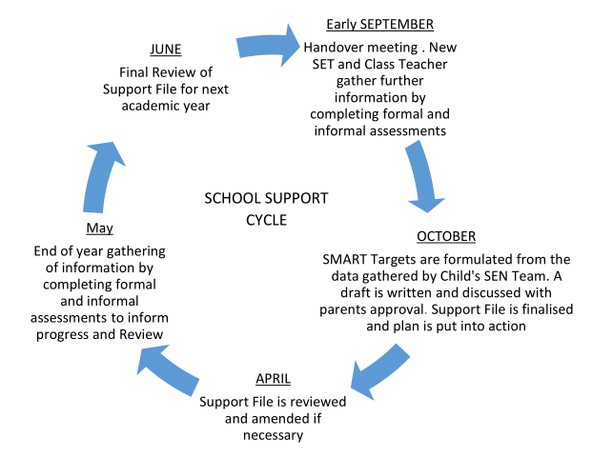
Setting Targets
Target setting is central to effective teaching for pupils with SEN. When setting targets, the following 4 guiding principles are adhered to:

Targets should be:
- linked to assessment.
- strengths based.
- linked to interventions.
- developed collaboratively (parents, teachers, pupils etc.)
Targets should also be few in number and be informed by priority learning needs. Teachers in collaboration with parents and pupils should choose 3 priority areas and select two targets in relation to those areas. If Maths is a target, then 1 target for each topic area is selected.

- They are based on evidence collected through both formal and informal assessment approaches.
- Targets should be expressed in a way that is measurable and observable, achievable within a specific timeframe but also challenge and build on existing knowledge of the pupil.
- Targets are set for a term and reviewed in March/End of Summer term.
- The Flow Chart below illustrates how target-setting is an integral part of the problem-solving framework to support pupils with special educational needs.
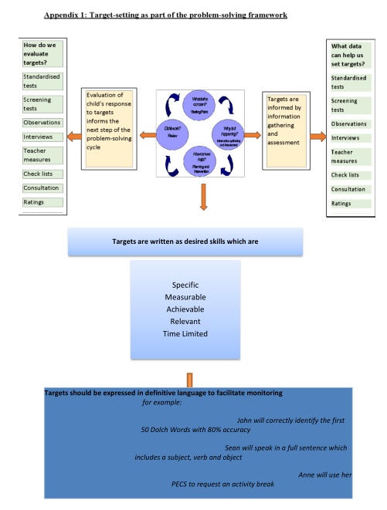
SEN RECORDS
Individual SEN Files
All pupils’ SEN files are stored on Aladdin and a paper copy is kept in a folder in a locked filing cabinet in the SEN room. It is the responsibility of the S.E.T to update and manage the files of the children on School Support and School Support Plus that they support. It is the responsibility of the Class teacher to update and manage the SEN files of children on Classroom Support. The following should be stored:

- Student Support Plan and Review
- Log of actions detailing support received, interventions, meetings with parents and other agencies, test administered and reviews during the year
- Results of Standardised and Diagnostic Tests
- The following details are stored in the pupils personal file in the SEN Room:
- Psychological Reports
- Copy of referrals made to outside agencies
- Copy of reports from outside agencies
- Record of SEN correspondence between parents, outside agencies and school staff
Communication between S.E.T/Principal/Class Teachers
The S.E.T. timetable has been organised so that 1.30-2:30 each Friday is designated S.E.T review/planning time. This allows the S.E.T the opportunity to meet with Class teachers and SEN Team meetings and SEN consultation/planning/review meetings, when necessary.
Health and Safety Issues
Every staff member and pupil is entitled to a safe, secure environment and to be treated with due respect. All appropriate measures are taken to ensure the safety of each pupil with SEN. When a place is offered to a child with SEN, every effort will be made to ensure that the supports to which the child is entitled are in place as soon as possible. Staff members will be informed of any potential risks and, where necessary, individual plans will be drawn up and implemented.

Supervision/Child Protection
- Where pupils receive support on a one-to-one basis, the S.E.T is responsible for ensuring that both they and the pupil are visible through the glass panel in the door / the door of the room remains open.
- Where pupils are withdrawn for support, the S.E.T should ensure the safe collection and return of children to their classrooms.
- Where a child has access to an SNA, the SNA may withdraw the child from the class if a plan is in place with the Class teacher.
Review and Implementation:
This policy will be reviewed every three years, most recently reviewed in April 2025.

Ratification and Communication:
The Board of Management of Coralstown National School has reviewed and ratified this plan on April 30th, 2025 and is available to all members of the school community.

Signed on behalf of The Board of Management:

Chairperson: _________________________ Date: 30/04/2025

Principal: _________________________ Date: 30/04/2025

Appendix 2

Exceptional Ability Policy

Definition and Background
‘An able child is one that achieves or has the ability to achieve at a level significantly in advance of their peer group. This may be in all areas of the curriculum or in a limited range’. (Eyre, 1999)

- Children who are considered gifted may have been assessed by a psychologist and found to have a high level of intelligence (an IQ score of 130+, 98th Percentile)
- Giftedness is recognised as a ‘disability’ or special education condition in the Education Act (1998)
School Ethos
We, the teaching staff at Coralstown National School have agreed to cater for those pupils who are exceptionally able in academic areas (i.e. the top 2% of the school population).

Those pupils who show exceptional talent in non-academic areas e.g. psychomotor ability, mechanical aptitude, visual and performing arts ability, will be given information regarding the relevant outside agencies.

Procedure for identification of pupils with Exceptional Ability

Criteria for Assessment
There is no single measurement with which to identify Exceptionally Able pupils due to their individuality. In order to recognise such pupils, we use a combination of the following sources of information:

1. A range of strategies may be used to identify Exceptionally Able pupils:

- Annual Standardised Tests – Percentiles over 90%
- NNRIT
- Psychological Assessments
- Teacher observation
- Written work produced by the child during lessons
- Views and opinions of the parents are taken into account
- View and opinions of the children themselves
- Referral by other individuals, schools or organisations
2. Where a teacher observes children displaying exceptional ability in a specific academic area, then further assessment may be carried out to establish giftedness. Where it is a non-academic area, the parent will be informed of outside agencies more suited to the development of the pupil’s exceptional ability.

Catering for Pupils with Exceptional Ability
Pupils who meet the criteria for Exceptionally Able (IQ of 130+) will be catered for within the classroom based on a differentiated programme of work or if deemed possible by the Principal may be offered extension classes on a withdrawal basis, subject to the approval of the pupil and their parents. These classes will form part of the S.E.T’s timetable.

The following in class strategies may be used:

- Creating a stimulating and positive learning environment so that the children feel motivated and engaged in their learning.
- High teacher expectations which ensures that the children always work to their best ability.
- Provide a secure classroom environment where the children feel safe therefore they are able to take risks which will challenge their thinking and learning – even if they experience failure sometimes.
- Teachers provide enrichment and extension opportunities for pupils as part of their planned differentiation.
Standards, Assessment for Learning, Monitoring and Evaluation
- Achievement tests and Public examinations – high performance on achievement tests can be used to identify gifted children. Examples of such tests include Drumcondra and NNRIT tests.
- Off-level testing – this kind of testing compares a student’s level of achievement on a test designed for much older students.
- Individual targets – targets are identified with each child so that they feel a sense of ownership and they are moving their own learning forward.
- Test results are assessed to ensure that the Exceptionally Able pupils are reaching their full potential as well as highlighting any new individuals who are working beyond the level of their peers.
Transfer and Transition
Information concerning Exceptionally Able pupils is passed on to the new class teacher at the end of each academic year to ensure that there is progression according to ability rather than age or phase. This is then used to inform planning of teaching and learning so that the Exceptionally Able children can be challenged from the first day that they move into their new class.

Responsibility and Management
1. The class teacher is responsible for:

- Identifying the Exceptionally Able children in their class.
- Supporting pupils in setting appropriate targets for themselves.
- Ensuring appropriate provision through differentiated planning.
- Using appropriate resources to challenge the Exceptionally Able children.
- Reporting to parents and others on the progress of the Exceptionally Able children.
- Monitoring the performance of the Exceptionally Able children.
- Ensuring the transfer of relevant information on the child to the next teacher.
2. The S.E.T will be responsible for the assessment stage of this process, organisation of extension classes including timetabling, acquisition and distribution of information regarding referral and assessment by outside agencies.

3. The Principal will liaise with parents, S.E.T and Class teachers throughout the process.

Staff Development
Teachers are given the opportunity to identify areas where professional development is required and identify suitable courses to further their understanding of the Exceptionally Able children. New members of staff are given support to ensure that they provide the best possible provision for Exceptionally Able children.

Engaging with the community, families and beyond

- The Irish Centre for Talented Youth (C.T.Y.I)
- Irish Association for gifted children (IAGC)
Parents are informed about the progress of their children during parent/teacher meetings and through written reports. They are always encouraged to support their child at home, which is fostered through practical and research-based homework tasks.

