Coralstown National School Coralstown,

### Mullingar,

### Co. Westmeath

E-mail:coralstown.info@gmail.com

[www.coralstown.ie](http://www.coralstown.ie)

Ph: 044 9374889

Principal: Michael Ward

Deputy Principal: Fiona Fox

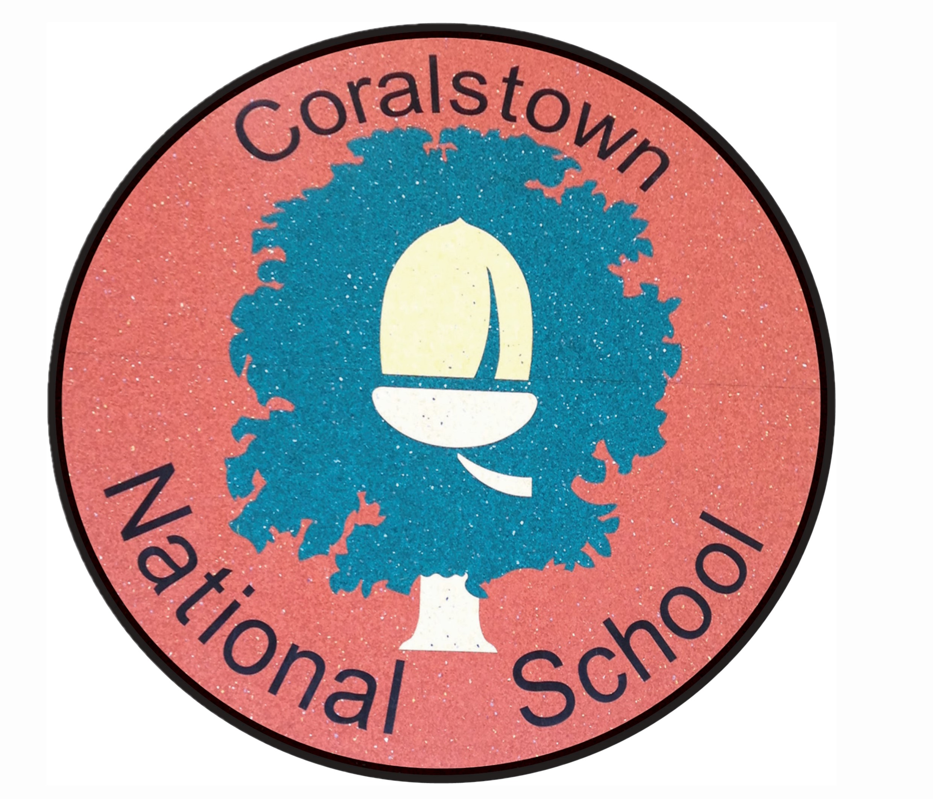

**Internet Acceptable Use Policy**

*This updated policy is subject to feedback from the school community and ratification by the Board of Management*

# **General Approach**

The aim of this Internet Acceptable Use Policy (AUP) is to ensure that the pupils of Coralstown NS will benefit from the learning opportunities offered by the school’s internet resources that information may be provided in a safe and effective manner.

Internet use and access is considered a school resource and privilege. If the school AUP is not adhered to this privilege may be withdrawn and appropriate sanctions will be imposed.

When using the internet pupils, parents and staff are expected:

* To treat others with respect at all times.
* Not undertake any actions that may bring the school into disrepute.
* Not undertake any action which may cause embarrassment or offence to a past or present member of staff or pupil of the school.
* Respect the right to privacy of all other members of the school community.
* Respect copyright and acknowledge creators when using online content and resources.

This Acceptable Use Policy applies to pupils who have access to and are users of the internet in Coralstown NS. It also applies to members of staff, volunteers, parents, carers and others who access the internet in Coralstown NS.

Misuse of the internet may result in disciplinary action, including written warnings, withdrawal of access privileges, detention and, in extreme cases, suspension or expulsion. The school also reserves the right to report any illegal activities to the appropriate authorities.

Coralstown NS will deal with where an incident arises outside the school that has an impact on the wellbeing of pupils or staff, Coralstown NS at its discretion may deal with this incident, and in doing so will refer to this policy and associated codes of behaviour and anti-bullying policies where applicable. In such cases Coralstown NS will, where known and where appropriate, inform parents/carers of incidents of inappropriate online behaviour that take place out of school and/or impose the appropriate sanctions and / or report to the appropriate authorities.

Coralstown NS implements the following strategies on promoting safer use of the internet:

* Pupils will be provided with education in the area of internet safety as part of our implementation of the SPHE curriculum.
* Teachers will be provided with continuing professional development opportunities in the area of internet safety.
* Parents will be provided with the opportunity to attend information sessions/workshops on internet safety and the correct use of the internet and digital media, once every two years (if feasible, to coincide with Safer Internet Day in February)
* Coralstown NS participates in Safer Internet Day activities to promote safer, more effective use of the internet and to promote awareness of the same among the wider school community.

This policy has been developed by a working group including: Principal, ICT Postholder, Digital Learning Team, teachers, parents/carers, and representatives of the Board of Management.

The implementation of this Internet Acceptable Use policy will be monitored by the principal, the ICT Postholder and the eLearning Team members. Should any serious online safety incidents take place, the principal should be informed.

# **Content Filtering**

Coralstown NS has chosen to implement content filtering on the Schools Broadband Network. This allows access to millions of websites including games and YouTube but blocks access to websites belonging to the personal websites category and websites such as Facebook belonging to the Social Networking category.

Web Browsing and Downloading

* Pupils will not intentionally visit internet sites that contain obscene, illegal, hateful or otherwise objectionable materials.
* Pupils will report accidental accessing of inappropriate materials in the classroom to their teacher.
* Pupils and staff will not share information from the internet without acknowledging the creator and referencing the source of the content.
* Pupils and staff will be aware that any usage, including distributing or receiving information, school-related or personal, may be monitored for unusual activity, security and/or network management reasons.
* Pupils will use the school’s internet connection only for educational and career development activities.
* Pupils will not engage in online activities such as uploading or downloading large files that result in heavy network traffic which impairs the service for other internet users.
* Pupils will not download or view any material that is illegal, obscene, and defamatory or that is intended to annoy or intimidate another person.
* Use of file sharing and torrent sites is not allowed.
* Downloading by pupils of materials or images not relevant to their studies is not allowed.

# **Email and Messaging**

* The use of personal email accounts is only allowed at Coralstown NS with expressed permission from members of the teaching staff.
* Pupils/staff will not send any material that is illegal, obscene, and defamatory or that is intended to annoy or intimidate another person.
* Pupils should immediately report to their class teacher the receipt of any communication that makes them feel uncomfortable, is offensive, discriminatory, threatening or bullying in nature and must not respond to any such communication.
* Pupils should avoid opening emails that appear suspicious. If in doubt, pupils should ask their teacher before opening emails from unknown senders.

# **Social Media**

The following statements apply to the use of messaging, blogging and video streaming services in Coralstown NS:

* Use of blogs such as Word Press, Tumblr etc. is allowed in Coralstown NS with express permission from teaching staff.
* Use of video streaming sites such as YouTube and Vimeo etc. is allowed with express permission from teaching staff.
* Staff and pupils must not use social media and the internet in any way to harass, insult, abuse or defame pupils, their family members, staff, other members of the Coralstown NS community.
* Staff and pupils must not share personal information about pupils, staff and other members of the Coralstown NS community on social media.
* Staff and pupils must not use school email addresses for setting up personal social media accounts or to communicate through such media.
* Staff and pupils must not engage in activities involving social media which might bring Coralstown NS into disrepute.

# **Personal Devices**

If permitted to use their own technology in school, pupils should follow the rules set out in this agreement, in the same way as if they were using school equipment. This use is also subject to the school BYOD (Bring your own device) policy.

The following statements apply to the use of personal internet-enabled devices in Coralstown NS (including, but not limited to, tablets, mobile phones, smart watches, gaming devices, digital music players etc):

* Pupils are only allowed to bring personal internet-enabled devices into Coralstown NS with expressed permission from staff.
* Pupils are only allowed to use personal internet-enabled devices in school with expressed permission from staff.

# **Images & Video**

* At Coralstown NS staff, pupils and parents must not take, use, share, publish or distribute images or recordings of others without their permission.
* Parents/carers are permitted to take photos or videos of their own children, on school grounds or when participating in school activities, once care is taken that no harm is done to staff or pupils of Coralstown NS. These photos/videos are for personal use only and should not be shared (see previous point)
* Care should be taken when taking photographic or video images that pupils are appropriately dressed and are not participating in activities that might bring the individuals or the school into disrepute or cause embarrassment to the individual.
* It is the school’s policy to celebrate the children’s work and achievements. As a result, images and/or videos of children and/or their work may appear on our school website and/or associated social media. Usually children will be only pictured at a distance and in groups, and children will not be identified by their full name. Permission from parents or carers to publish photographs of pupils and/or their work on the school website and/or associated digital media accounts, will be requested as part of the enrolment process and will also be requested again at the start of every school year.
* Pupils may not take photos or videos on school grounds or when participating in school activities, except with expressed prior permission from staff.
* Pupils and parents must not share images, videos or other content online with the intention to harm another member of the school community regardless of whether this happens in school or outside.
* Sharing explicit images and in particular explicit images of pupils and/or minors is an unacceptable and absolutely prohibited behaviour, with serious consequences and sanctions for those involved. Sharing explicit images of other pupils and staff automatically incurs suspension as a sanction and any such sharing by any party will be reported to the appropriate authorities

# **Google Meet App**

* During occasions of school closures that require distance learning, the pupils may be invited to participate in a video call, hosted by their teacher via the Google Meet app (this integrates easily with the Google Classroom app). Typically, this will involve the pupil’s teacher sending out a link to a Google Meet, for a certain time, on a certain day, via Google Classroom. Some of the included safety measures and expected protocols include:
* Pupils must be logged into their @coralstown.ie account to gain access
* Pupils will not be able to join the meeting until their teacher has joined first.
* Pupils and families should make sure that the laptop or device is set up in a place that doesn't have too much background noise or passing traffic. Also for the privacy and privacy of family and home, the device should be set up where the other meeting members won't have an open view of the house, family members etc.
* Parents are welcome to sit with their child.
* Pupils should be shown how to mute and unmute their microphone. This means that unnecessary background noise can be eliminated and the teacher can ask a specific child to unmute and speak to the group as appropriate/relevant.
* As always, appropriate and respectful behaviour is expected during these video calls. Any interactions with the school's Google for Education platform and its associated apps must be in line with this Internet Acceptable Use Policy. In particular, the meeting must not be recorded or photographed (c.f previous paragraph). Any breaches of this policy will result in a child's internet privileges and school accounts being revoked and other sanctions as appropriate.

# **Cyberbullying**

* When using the internet pupils, parents and staff are expected to treat others with respect at all times.
* Engaging in online activities with the intention to harm, harass, or embarrass and another pupil or member of staff is an unacceptable and absolutely prohibited behaviour, with serious consequences and sanctions for those involved.
* Measures are taken by Coralstown NS to ensure that staff and pupils are aware that bullying is defined as unwanted negative behaviour, verbal, psychological or physical, conducted by an individual or group against another person (or persons) and which is repeated over time. This definition includes cyber-bullying even when it happens outside the school or at night.
* Isolated or once-off incidents of intentional negative behaviour, including a once-off offensive or hurtful text message or other private messaging, do not fall within the definition of bullying and will be dealt with, as appropriate, in accordance with the school’s code of behaviour and /or this policy.

The prevention of cyber bullying is an integral part of the anti-bullying policy of our school.

# **School Websites & associated Social Media**

It is the school’s policy to celebrate the work and achievements of our pupils. As a result, images, audio and/or video clips of pupils and/or their work will be published on our school website and/or associated social media.

* Usually pupils will be only pictured at a distance and in groups.
* Coralstown NS will avoid identifying any pupils by their full name.
* The publication of student work and images will be coordinated by a teacher.
* Personal student information including home address and contact details will not be published on Coralstown NS web pages.

This updated policy is subject to feedback from the school community and ratification by the Board of Management

This policy was reviewed by the Board of Management on 28th February 2025.

Signed: _________________________ Signed: __________________________

Chairperson of Board of Management Principal

Date: 28th February 2025