Appendix 3 Enrolment Form
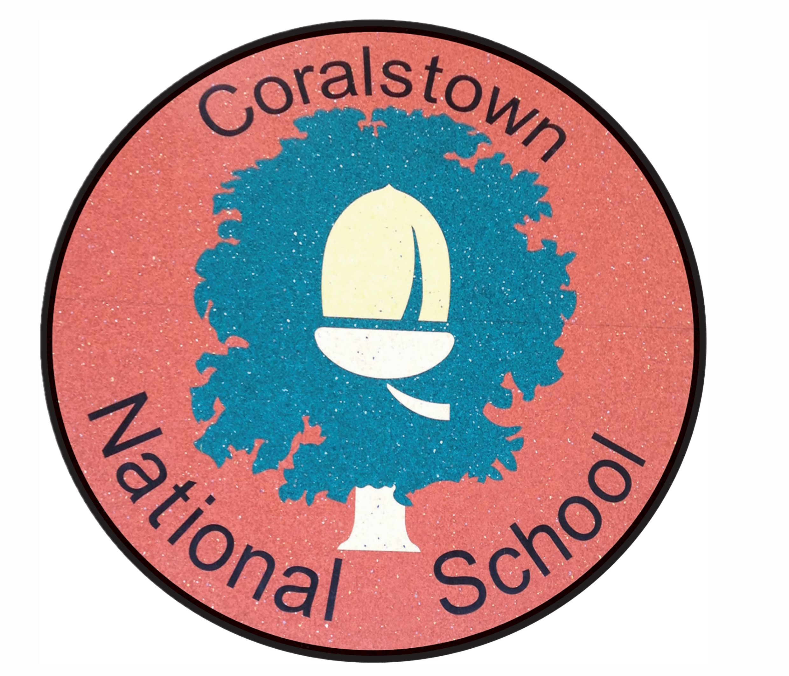
Email:coralstownns.info@gmail.com
www.coralstown.ie
Ph: 044 9374889
Principal: Micheal Ward
Deputy Principal: Fiona Fox
Coralstown National School Coralstown,

Mullingar,

Co. Westmeath

Enrolment Form 2026 - 2027
First Name: _______________________ Surname: ______________________________
Date of Birth: _______________________ Home Tel No: ___________________________
Address: _______________________________________________________________________

Mother/Guardian’s Name: __________________________ Mobile No: ________________
Address: _______________________________________ Work No: ________________
_______________________________________ Home No: ________________
Eircode: _______________________________________
Email Address:_________________________________________________________________

Father/Guardian’s Name: __________________________ Mobile No: ________________
Address: _______________________________________ Work No: ________________
_______________________________________ Home No: ________________
Eircode: _______________________________________
Email Address:_________________________________________________________________
Names of brothers / sisters in this school: _______________________________________________________________________________

